Analysis of Profitability Issues in the Central Region
Student ID:
Student Name:
Course: 2030AFE Business Intelligence

Executive Summary
This report aim to investigates the significant underperformance in profitability of OfficeWorld's Central region. By using the Power BI to create interactive dashboard to calculate the sales and profit data from 2014-2017, then analyze and seek out a critical issue.
The dashboard provides some insights, for instance a key finding is that the furniture category within the central area is the primary driver of poor performance, generating substantial sales but suffering near-zero profitability.
This is correlated with an unsustainable discounting strategy, where average discount rates for furniture in this region are high, and particularly within the Consumer segment.
It is recommended that OfficeWorld should implement a cap on discount rates for Furniture in the Central region, launches a targeted marketing initiative to promote more profitable product categories like technology and OfficeSupplies, and realigns sales team incentives to prioritize profit margins over pure sales volume.

1. Introduction
This report examines a big business issue currently affecting OfficeWorld is the consistently low profitability in its Central sales region. The main target is to focus on identify the hidden causes of this problem by using this dashboard and to suggest practical recommendations for improvement.
The analysis is based on OfficeWorld’s internal sales dataset, with a focus on three key performance indicators: sales revenue, profit margins, and the other relationship related between them (like across different regions, product categories, and customer segments).
Using filters and drill-down features in order to reveal specific trends and point out what factors have most responsible for the poor financial performance.

2. Defining the Hypothetical Business Problem
While OfficeWorld's national sales figures appear robust, a regional overview reveals a critical vulnerability: The Central region is significantly underperforming, with profit margins that are lower than its sales contribution.
While other regions demonstrate a healthy relationship between sales volume and profit, the Central region's profit is nearly flat, indicating severe margin erosion. This issue is a major concern for the business.
An area that fails to convert sales into profit represents a drain on resources and a missed opportunity for growth and development can puts pressure on more successful regions to cover the shortfall and threatens the company's overall financial stability.
If this stituation left unaddressed, the practices leading to this poor performance could spread, causing huge gap for the company-wide profitability later on. This analysis therefore seeks to diagnose the precise causes of the Central region's weak performance to enable targeted corrective action.

3. Analysis and Findings

3.1. Overall Trend Analysis:
At a national level, OfficeWorld's performance from 2014-2017 appears positive, with total sales reaching $2.30 million and a total profit of $286.4K.
The line chart tracking performance over time shows consistent sales activity with seasonal peaks, particularly in the fourth quarter of each year.
This high-level view (Figure 1) confirms the business is operationally active but does not immediately reveal underlying regional weaknesses, the data spreading not distribute evenly, leading many questions and concerns.
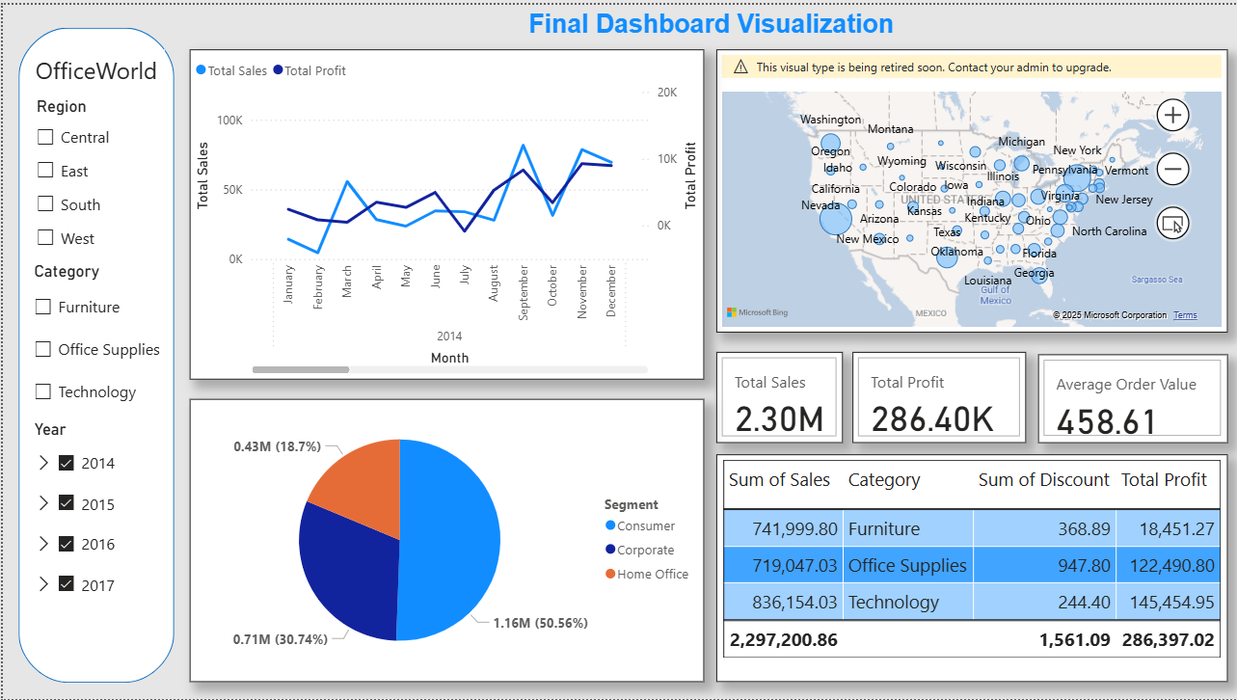
Figure 1: Main Dashboard View Showing Overall KPIs and Sales/Profit Trend

3.2. Deeper Dive by Category/Region (or other dimensions):
To analyze regional contributions, the dashboard was filtered by region (selected in the filter for reviewing) . This action immediately highlighted the disparity in performance.
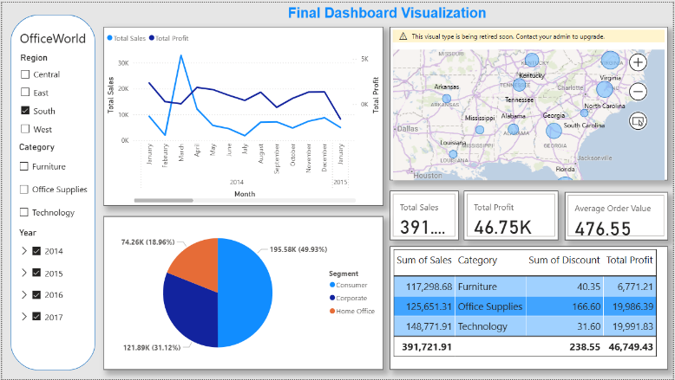
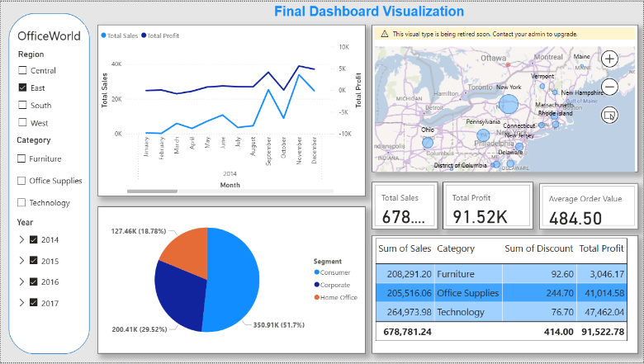
Region comparation:
Figure 2: Main Dashboard View Showing Overall (Select South Area)
Figure 3: Main Dashboard View Showing Overall (Select East Area)
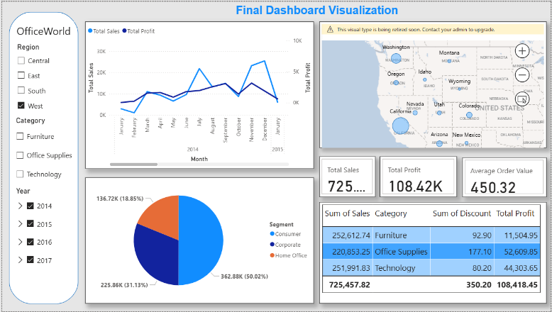
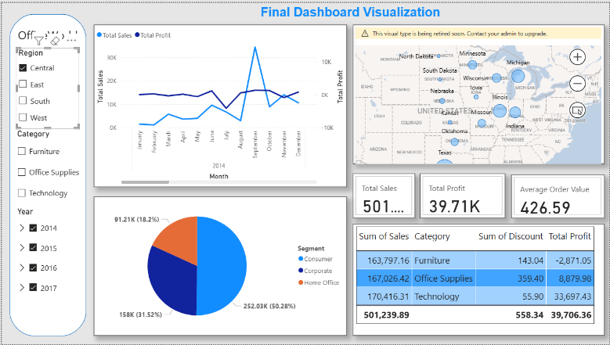
Figure 4: Main Dashboard View Showing Overall (Select West Area)
Figure 5: Main Dashboard View Showing Overall (Select Central Area)
Key Insights and Comparisons
1. West is the Top Performing Region: The West region leads in every key performance metric (highest total sales, total profit, average order value).
2. The Central Region has a Severe Profitability Problem: underperformace due to lowest order value. Although having the 2nd place in sales, giving lowest profit of all the regions.
3. Customer Segment Distribution is Consistent:
The Consumer segment is the largest sales driver in all four regions, accounting for:
- 55.29% in the South
- 52.35% in the West
- 48.11% in the East
- 46.51% in the Central region
The Corporate segment is consistently the second-largest, followed by the Home Office segment across all regions.

3.1 Root Cause Identification:
Still filtering and see that ‘Furniture’ is a stark insight. Despite accounting for over 35% of the region's sales, was generating almost no profit. In another word, 'Office Supplies' and 'Technology' remained reasonably profitable. This finding pinpoints the issue not just to a region, but to a specific product category within it.
The data reveals a clear correlation between sales of furniture items and extremely high discount rates, frequently ranging from 30% to 50%.
These discount levels are higher than those applied to Furniture in other regions and are far above the rates for other categories within the Central region.

4. Proposed Solutions and Recommendations
The findings from the dashboard analysis lead to the following actionable recommendations, designed to restore profitability to the Central region.

Recommendation 1: Launch a Targeted Product Bundling Initiative.
- Justification: The dashboard showed that 'Office Supplies' and 'Technology' products are profitable in the Central region. These high-margin products can be leveraged to improve overall transaction value.
- Action: Create and promote product bundles that pair popular but low-margin furniture items with high-margin accessories (e.g., a desk bundled with a lamp, chair mat, and surge protector). This initiative should be marketed heavily to the 'Consumer' segment in the Central region.

Recommendation 2: Revise and Cap Discounting Strategy.
- Justification: The analysis conclusively shows that the primary cause of unprofitability in the Central region is the excessive discounting of Furniture products.
- Action: Implement a mandatory discount cap of 15% for all products in the Furniture category within the Central region. This rate is in line with the national average for the category and will immediately improve profit margins on every sale. The regional sales manager must be responsible for enforcing this new policy.

Recommendation 3: Performance Review for Specific Segments.
- Justification: "The dashboard highlighted that the 'Consumer' segment in the West region disproportionately utilized the highest discounts."
- Action: "Conduct a quarterly performance review with the West region's sales team to adjust their local discounting policies for the Consumer segment."

5. Conclusion
In conclusion, this report successfully addressed the business problem of poor profitability in OfficeWorld's Central region.
The root cause was identified not as a lack of sales, but as a systemic issue of margin erosion within the Furniture category, driven by an unsustainable discounting strategy.
By leveraging the Power BI dashboard, we were able to drill down from a national overview to a specific, actionable insight. Recommendations: capping discounts, promoting profitable product bundles, and realigning sales incentives, provide a clear, data-driven path forward.
Implementing these solutions is expected to restore the Central region to profitability within the next two quarters, strengthening OfficeWorld's overall financial health.

